Pseudocode

Display Harry Staley

8884 Staghorn Mill, Converse, TX 78109

330-718-1876

Computer Science

Compile Screenshot

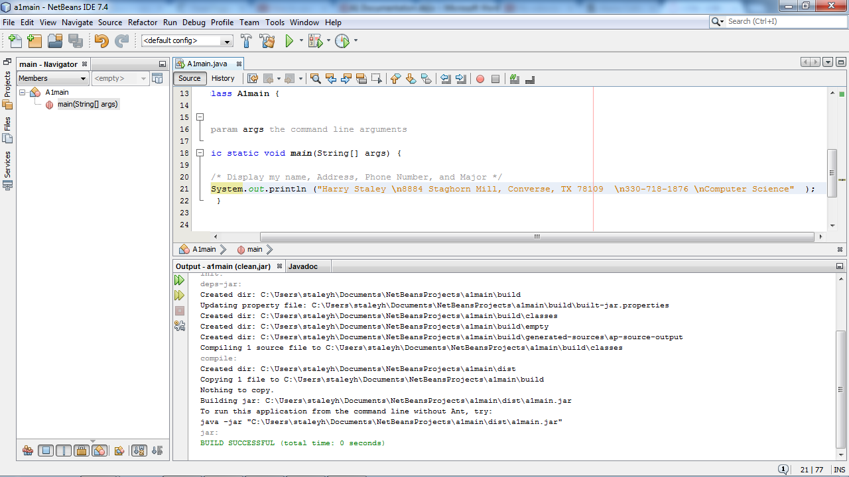

Run Screenshot

